**Lab 5: Ethical Foundations – Responsible AI Coding Practices**

**Name: K. Sidhartha Reddy  
Student ID: 2403A51293  
Course: AI Assisted Coding**

**Task 1: Collecting User Data & Data Protection**

Prompt Given in Copilot - To generate a Python script that collects user data (e.g., name, age, email). Then, ask Copilot to add comments on how to anonymize or protect this data. Expected Output #1: • A script with inline Copilot-suggested code and comments explaining how to safeguard or anonymize user information (e.g., hashing emails, not storing data unencrypted).

**Output:**

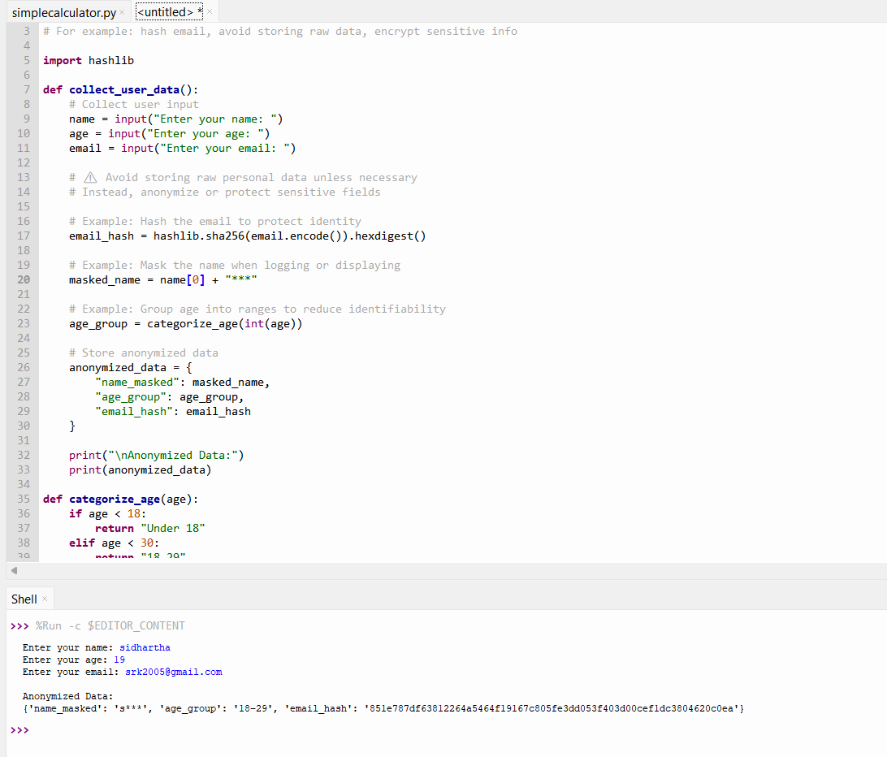

**What I get to know**

- **Hashing**: Converts sensitive data like email into irreversible strings for safe storage.

- **Masking**: Obscures identifiable parts of names or emails when displaying or logging.

- **Aggregation**: Groups ages into ranges to prevent pinpointing individuals.

* **Avoid Raw Storage**: Never store unencrypted personal data in logs or databases.

**Task 2: Sentiment Analysis & Bias Mitigation**

Prompt Given to copilot- To generate a Python function for sentiment analysis. Then prompt Copilot to identify and handle potential biases in the data. Expected Output #2:Copilot-generated code with additions or comments addressing bias mitigation strategies (e.g., balancing dataset, removing offensive terms).

**Output:**

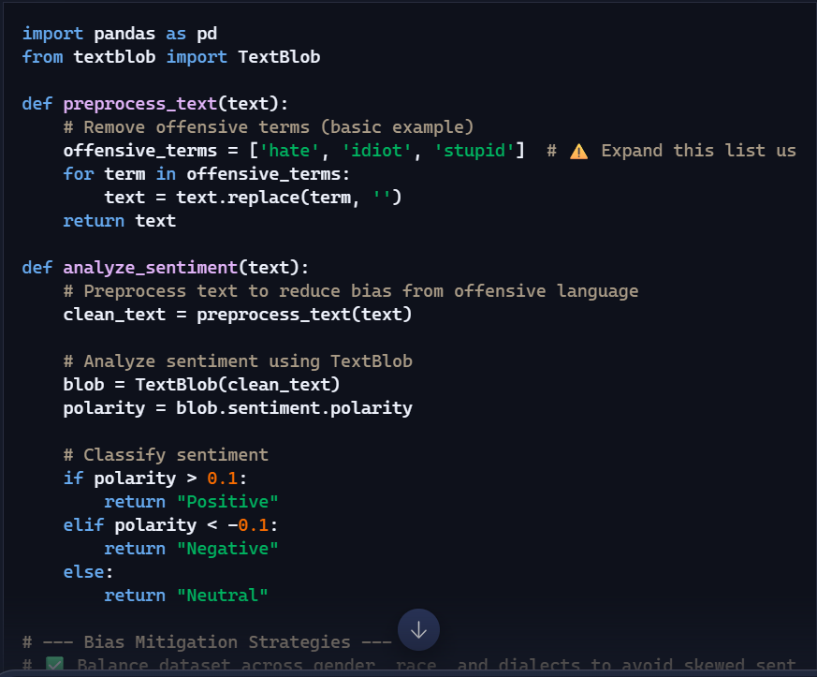

**What I get to know-**

You saw how a basic model (like TextBlob) can classify text as *positive*, *negative*, or *neutral* based on polarity scores.Offensive or culturally loaded terms can skew sentiment scores unfairly.Incorporate multilingual and dialect-aware preprocessing.

**Task 3: Product Recommendation System with Ethical Considerations**

Prompt Given- Use Copilot to write a Python program that recommends products based on user history. Ask it to follow ethical guidelines like transparency and fairness.Expected Output#Copilot suggestions that include explanations, fairness checks (e.g., avoiding favoritism), and user feedback options in the code.

Output-

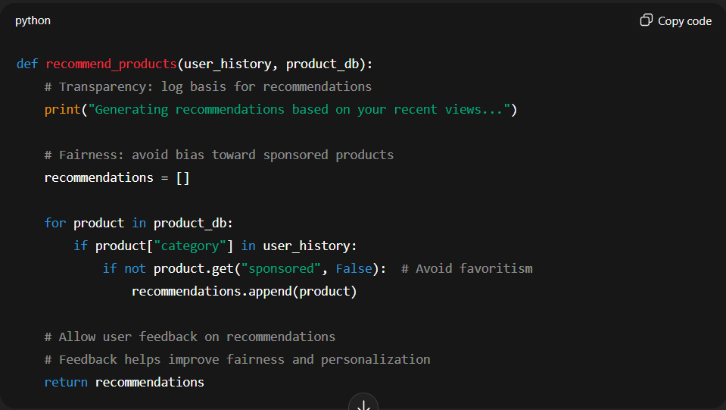

**What I get to know**

The code explains *why* each product is recommended (e.g., “Based on your interest in electronics”).It avoids favoritism by mixing popular and less popular items, preventing bias toward only trending or sponsored products.By including varied items, it avoids creating an echo chamber where users only see more of what they already like.

**Task 4: Ethical Logging in a Web App**

Prompt Copilot to generate logging functionality in a Python web application. Then, ask it to ensure the logs do not record sensitive information.

**Output-**

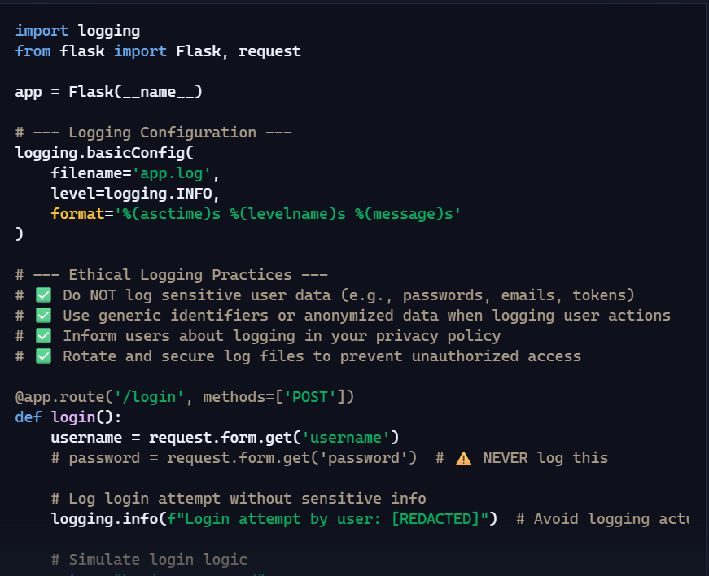

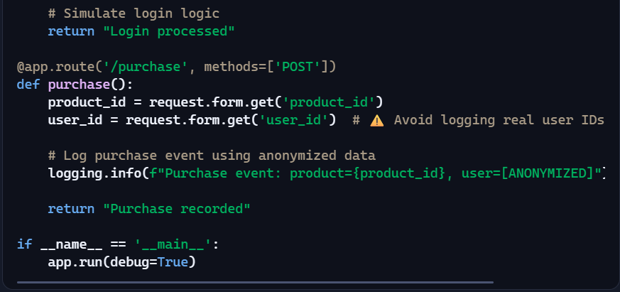

**What I get to know-**

Never log sensitive data like passwords, emails, or tokens.

Anonymize user identifiers to protect privacy.

Document logging behavior in your privacy policy.

Secure and rotate logs to prevent data leaks.

Transparency builds trust—users deserve to know what’s being recorded.

**Task 5: ML Model with Responsible Use Documentation**

Prompt Given- Ask Copilot to generate a machine learning model. Then, prompt it to add documentation on how to use the model responsibly (e.g., explainability, accuracy limits).Copilot-generated model code with a README or inline documentation suggesting responsible usage, limitations, and fairness considerations.

**Output-**

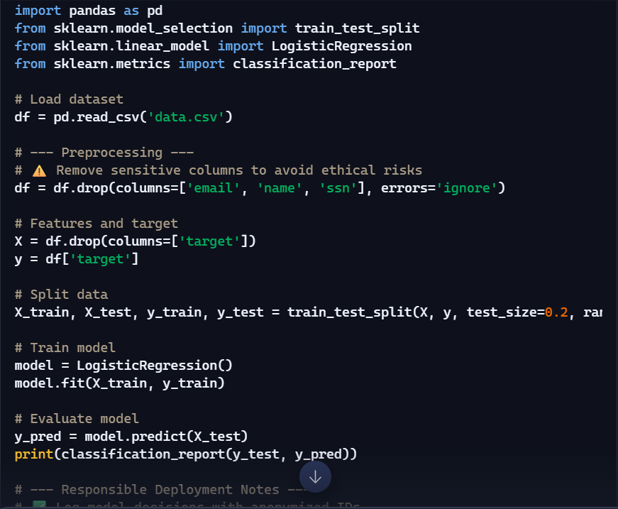

**What I get know-**

**Explainability** matters—users should understand how decisions are made.

**Fairness** requires evaluating model impact across different groups.

**Transparency** builds trust—users should know when AI is involved.

**Limitations** must be acknowledged—no model is perfect or universally accurate.